

SubstrateX® Longitudinal Labs
Instrumenting Intelligence in Motion™

Validating Longitudinal Computational Dynamics: Deterministic Runtime Evidence and Discrimination of Computational Regime Transitions

SubstrateX® Longitudinal Computational Dynamics Series ·
Paper 2 · Version 1.0 · October 2026

Author: Arjay Asadi
Position: Founding Architect, SubstrateX®
Affiliation: SubstrateX® Longitudinal Labs
Research: Longitudinal Computational Dynamics · Longitudinal Computational Behavior · Evidence-Governed Computation · Runtime Evidence Infrastructure
Correspondence: arjay.asadi@substratex.ai
Web: www.arjayasadi.com

© 2026 Arjay Asadi. All Rights Reserved.
Research Access: Non-Commercial Research & Intellectual Exchange Only.

Table of Content

Abstract
Longitudinal Computational Dynamics (LCD) is the scientific study of observable computational behavior across extended runtime. Its empirical object, Longitudinal Computational Behavior, is reconstructed from source-bound operational records through declared methods rather than inferred as direct access to hidden model state. The foundational LCD paper defines the scientific object and its principal constructs: trajectory, recurrence, drift, stability, regime, boundary formation, Basin Exit, collapse, recovery, and re-entry. This companion paper addresses the first two validation propositions attached to that framework.
The first proposition concerns computational reproducibility: the same qualified source, configuration, canonicalization method, and governing versions should reproduce the same deterministic evidence identity and core Runtime Evidence Record. The second concerns scientific discrimination: selected longitudinal measurements should distinguish specified transition cases from stable and negative controls more effectively than declared simple baselines. Both propositions are reported as confirmed within the controlled SubstrateX Aperture™ validation program.
The program currently identifies 26 reported validation cases, eight operational samples, one source-bound 160-turn fixture, fourteen validation protocols, a 25-entry runtime Signal Authority, and a 28-signal research-facing registry. Validation uses a two-object architecture: Aperture computes a Runtime Evidence Record without access to expected outcomes; a separate Validation Comparison Record evaluates that result against a locked expectation map. This separation prevents sample identity, expected labels, case framing, rubric scores, and interface state from becoming evidence inputs.
The present public record supports the two directional findings but does not yet bind a complete case manifest, repeat counts, case-level numerical results, uncertainty intervals, effect sizes, false-positive and false-negative tables, full ablation outputs, or frozen release and artifact hashes. Those quantities are therefore not inferred or reconstructed in this paper. The result is a bounded validation report: it states what has been established, specifies the methods and reporting objects required to reproduce the claims, and records the remaining publication dependencies. It does not claim universal validity, production-level prediction, causal explanation, hidden-state access, cross-domain generalization, or independent replication.
Keywords: Longitudinal Computational Dynamics; Longitudinal Computational Behavior; Runtime Evidence; regime transition; deterministic replay; scientific discrimination; negative controls; Evidence-Governed Computation; SubstrateX Aperture

Introduction
Contemporary computational evaluation is often organized around endpoints. A model produces an answer, an agent completes or fails a task, a tool call succeeds or errors, or a benchmark assigns a score. These observations are important, but they do not fully characterize systems whose behavior develops through many dependent steps. Long-horizon agents accumulate context, interact with tools, coordinate with people and other agents, revise earlier work, inherit constraints, and encounter disturbances whose effects may form gradually.
LCD changes the unit of analysis from the isolated output to the source-bound runtime trajectory [1]. It asks how observable computational organization forms, moves, persists, destabilizes, crosses declared boundaries, collapses, recovers, and re-enters admissible conditions through time. This orientation is related to dynamical-systems analysis, change-point detection, process mining, agent trajectory analysis, provenance, and runtime observability [2-11], but it introduces a distinct evidentiary requirement: every scientific finding must remain traceable to an admissible record, a declared measurement method, an evidence horizon, and a bounded claim.
The foundational paper established the field and its scientific vocabulary. A field, however, becomes credible through discriminating tests rather than definitions alone. Two early propositions are especially important.
First, an evidence-governed observatory must behave as an instrument rather than a persuasive visualization. If the same evidence and governing versions can yield different core records, later scientific comparisons become unstable. Deterministic replay is therefore a necessary computational proposition.
Second, deterministic output is not sufficient. A perfectly repeatable metric may still fail to distinguish a transition from ordinary variation. Selected LCD measurements must show discriminative value against stable and negative controls and against simpler reference methods. This is the first scientific proposition examined here.
The validation problem therefore has two axes:
- Can the evidence computation be reproduced?
- Does the measurement distinguish the specified phenomenon under controlled conditions?
These questions must remain separate. Computational reproducibility tests the governed transformation from source to evidence. Scientific discrimination tests whether selected measurements differentiate declared case classes. Neither result establishes hidden model state, universal prediction, causal explanation, or validity outside the tested conditions.
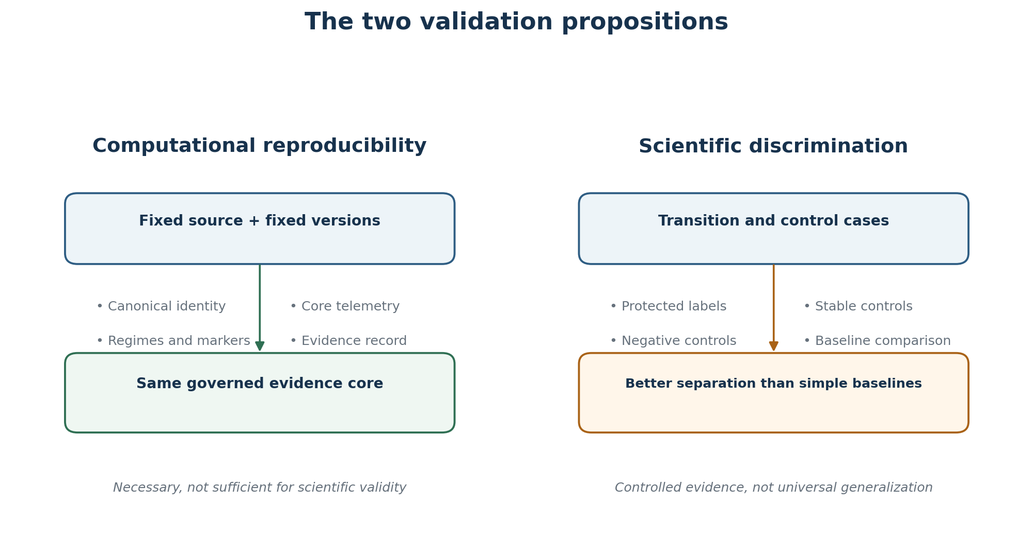
Figure 1. Computational reproducibility and scientific discrimination are distinct validation propositions.

Research Questions and Locked Propositions

Research questions
RQ1 — Computational reproducibility. Given the same qualified source, declared configuration, canonicalization method, implementation release, registries, and governing method versions, does Aperture reproduce the same deterministic evidence identity and core Runtime Evidence Record?
RQ2 — Scientific discrimination. Under controlled case definitions, do selected longitudinal measurements distinguish known transition cases from stable and negative controls better than declared simple baselines?
RQ3 — Boundary discipline. Does the validation architecture preserve unavailable evidence, candidate conditions, failure anchors, and claim limits without converting them into stronger findings?
RQ4 — Replication readiness. Which objects, versions, results, and hashes are available for independent reproduction, and which remain unbound in the current public record?

Locked propositions
The validation program uses expectation maps declared and locked before evidence computation. In this architecture, a proposition is prospectively specified within the Evidence Chamber and remains unavailable to the runtime evidence engine until comparison. This is an internal prospective-declaration control. The materials reviewed for this paper do not establish a separate public, time-stamped third-party preregistration, so that stronger term is not asserted.
P1 — Deterministic evidence reproduction. For fixed qualified source bytes or source identity, adapter and canonicalization configuration, computation configuration, and governing versions, the deterministic evidence core is invariant under eligible replay.
P2 — Controlled transition discrimination. For the declared controlled cases, the selected LCD measurement set separates specified transition cases from stable and negative controls more effectively than the declared simple baselines.
P3 — Non-amplification of absent evidence. Missing, unavailable, not-observed, candidate-only, or inadmissible evidence remains represented as such and is not silently converted into zero, stability, failure, or confirmation.
P1 and P2 are the principal propositions reported as confirmed. P3 is an architectural conformance proposition that governs interpretation of those results.

Scientific and Evidentiary Scope

Empirical object
The empirical object is Longitudinal Computational Behavior: the observable pattern of computational organization supported by an ordered, source-bound record. A record may contain messages, tool calls, timestamps, role changes, retries, alerts, workflow events, corrections, deployments, or other observable operational events.
The object is not a hidden internal trajectory. LCD does not infer private reasoning, neural activation, subjective experience, intent, consciousness, or an inaccessible model state. It studies the organization that can be reconstructed from the supplied record under declared methods.

Reference implementation
SubstrateX Aperture™ is the reference implementation used by the controlled validation program. Aperture qualifies heterogeneous sources, constructs a canonical runtime, computes registered behavioral telemetry, forms a Current Evidence Run, issues bounded Instrument Findings, and preserves the resulting Runtime Evidence Record with a Runtime Evidence Passport and claim boundary.
Aperture is evidence for implementability, not the definition of the field. An independent implementation can test the same scientific propositions if it publishes equivalent source, canonicalization, measurement, temporal, comparison, and claim contracts.

Validation claim classes
Table 1. Validation claim classes and authority boundaries.
Claim class | Question answered | Required evidence | Not established by the result
Computational reproducibility | Does the governed transformation reproduce? | Bound source, fixed versions, equality rules, repeat executions, comparison record | Scientific validity or external generalization
Controlled discrimination | Does a measurement distinguish declared case classes? | Labeled cases, controls, baselines, locked methods, held-out or otherwise protected evaluation | Causation, production prediction, universal diagnosis
Construct validity | Does the measure represent the intended scientific construct? | Convergent, discriminant, ablation, sensitivity, and external-criterion evidence | Hidden-state access or metaphysical interpretation
Predictive validity | Does a prospective signal predict a later independently anchored outcome? | Eligible evidence horizon, held-out cases, independent outcome anchors, calibration | Retrospective explanation alone
External validity | Does the result transport across source families, systems, models, and institutions? | Independent datasets and prespecified transfer analyses | Performance within controlled fixtures
Independent replication | Can an unaffiliated party reproduce the result? | Complete release bundle, executable protocol, published discrepancies | Internal replay or same-team rerun

The central claim of this paper is limited to the first two classes under controlled conditions.

Validation Architecture

The two-object model
Validation is implemented through two separately identifiable objects.
The Runtime Evidence Record contains what Aperture computes from the scenario source through the ordinary production pipeline. It must be formed without access to fixture labels, expected markers, rubric scores, comparison results, or target narrative.
The Validation Comparison Record compares the completed evidence record with a locked expectation map. It may classify the comparison as matched, partially matched, not matched, unexpected, unavailable, or inadmissible. It cannot rewrite the source, canonical runtime, telemetry, markers, Instrument Findings, Passport, Evidence Seal, or evidence identity.
This separation is the principal anti-contamination mechanism:
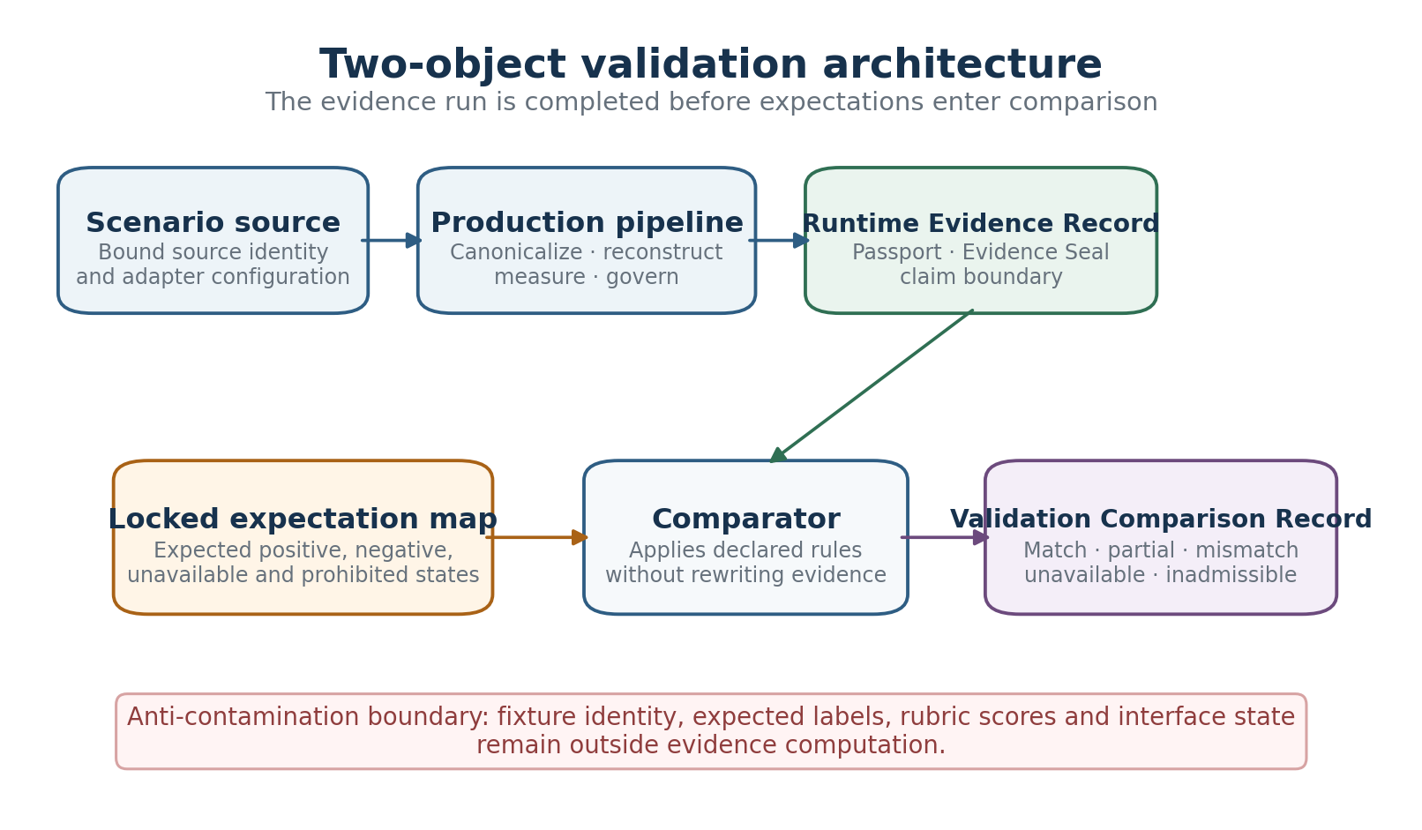
Figure 2. Two-object validation architecture and anti-contamination boundary.
Expectation is test context—not evidence input.

Evidence path
The computational path is:
Scenario source → qualification and versioned canonicalization → runtime reconstruction and registered measurement → Current Evidence Run → Runtime Evidence Record, Passport, and Evidence Seal
The comparison path begins only after evidence formation:
Locked expectation map + issued evidence record → Validation Comparison Record → preserved validation artifact

Anti-contamination rules
The evidence engine may use only declared ordinary run inputs: the preserved source, applied adapter, canonicalization configuration, registered methods, thresholds, schemas, and source or operator context that would be available in a non-validation run.
The following are excluded from evidence computation:
- scenario title and sample identity;
- fixture metadata describing the expected result;
- expected class, regime, marker, or finding;
- validation rubric scores;
- case narrative written to explain the fixture;
- target Human Read language;
- comparison status; and
- interface or cockpit state.
These objects may be evaluated after computation. They may not participate in telemetry, regime classification, marker formation, Instrument Findings, REIM scoring, Human Read, Passport issuance, or the Evidence Seal.

Comparison states
Table 2. Validation comparison states.
State | Interpretation
Matched | The observed evidence satisfies the locked condition under the declared comparison rule.
Partially matched | Some required conditions are satisfied; one or more remain incomplete or unsupported.
Not matched | The expected condition is not supported by the observed evidence.
Unexpected finding | An undeclared finding was produced and retained for inspection.
Unavailable | Required source coverage, dependency, marker, or authority is missing.
Inadmissible | The requested comparison exceeds the evidence, method, calibration, or claim contract.

Materials and Case Composition

Reported program inventory
The current technical baseline is identified as FG-TVS-2026.1, Version 1.0.0. The reviewed implementation snapshot is RL1331. The published technical materials report:
- 26 validation cases;
- eight operational samples;
- one source-bound 160-turn fixture;
- seven implementation-bound Operational World profiles;
- fourteen validation protocols;
- nine instrument contracts;
- a 25-entry runtime Signal Authority; and
- a 28-signal research-facing semantic registry.
The 25 and 28 counts refer to different layers. The runtime count describes implemented Signal Authority entries in RL1331; the research count describes semantic signal contracts. They must be connected through a versioned crosswalk and must not be treated as interchangeable.
The 26 reported cases are an inventory count, not necessarily 26 statistically independent experimental units. The current public record does not bind the complete case manifest, dependence structure, repeat count, or class distribution. Consequently, this paper does not use 26 as an inferential sample size.

Required case families
Table 3. Required validation case families.
Case family | Scientific purpose | Required interpretation behavior
Stable | Establish ordinary persistent organization | No unsupported boundary, collapse, failure, or lead-time claim
Transitional | Represent declared weakening or regime movement | Detect the specified transition while preserving candidate and confirmed states
Negative control | Represent absence of the target phenomenon | Refrain from manufacturing the target finding
Ambiguous or contradictory | Test competing evidence and weak separation | Preserve alternatives, uncertainty, and unresolved classification
Missing evidence | Remove a required dependency or marker | Return unavailable, not supplied, or inadmissible rather than a fabricated value
Perturbed | Apply a controlled change to source structure or content | Change only outputs legitimately dependent on the perturbation
Cross-source-family | Express related behavior through different operational records | Preserve source semantics while testing transport of declared measurements

Source families
The validation architecture supports controlled and operational sources from monitoring and reliability, workflow coordination, software engineering and continuous integration, security operations and SIEM, cloud infrastructure, attention and long-horizon work, agent and tool workflows, and determinism or conformance testing.
Synthetic fixtures, controlled multistage scenarios, regression cases, stable controls, and real-log alternates must remain distinguishable. A synthetic case is useful for isolating a construct; it is not evidence that the construct generalizes to uncontrolled operational data. A real-log alternate may improve ecological relevance; it does not become ground truth without an independent outcome and provenance record.

Inclusion rules
A case is eligible for a computational reproducibility analysis when it has:
- a stable source identity or exact source bytes;
- declared adapter and canonicalization versions;
- fixed computation configuration and governing registries;
- a defined deterministic core and equality rule;
- at least two eligible executions; and
- a comparison record that distinguishes governed output from variable envelope metadata.
A case is eligible for scientific discrimination analysis when it additionally has:
- a target case class established independently of the tested measurements;
- a stable or negative-control comparison condition;
- a locked feature and measurement specification;
- a declared baseline;
- an eligible evidence horizon;
- a rule for ambiguous and missing evidence; and
- a protected evaluation procedure appropriate to the size and dependence of the corpus.

Exclusion rules
A case is excluded from the corresponding analysis when source identity cannot be resolved, canonicalization is materially ambiguous, the expected result entered the evidence computation, a label was created from the measurement being evaluated, the eligible evidence horizon includes prohibited future information, required dependencies are unavailable, or the case is a presentation-only demonstration without a bound comparison contract.
Exclusion from one analysis does not require deletion. The case may remain useful for engineering, qualitative inspection, failure analysis, or method development if its status is explicit.

Measurement and Runtime Definitions

Observable runtime state
For a qualified record with ordered runtime units indexed by t, the observable runtime state is represented as a versioned feature vector x(t) computed only from the admissible evidence horizon H(t). The feature vector may include source-derived properties, derived runtime dynamics, and bounded projections, provided each component discloses its dependencies, method, temporal scope, availability, and claim class.

Longitudinal measurement families
The LCD validation target is not one universal score. Candidate measurement families include:
- motion and drift;
- coherence and continuity;
- temporal organization and recurrence;
- contraction and pressure;
- regime persistence and transition pressure;
- boundary formation and Basin Exit support;
- role and interaction dynamics;
- recovery and re-entry; and
- cross-signal relationships.
The exact selected subset used in a discrimination result must be identified by registry ID, implementation mapping, parameters, thresholds, and evidence horizon. The current public record confirms that a selected set was evaluated but does not expose the complete case-level feature matrix or the exact baseline-to-measurement mapping. No unlisted metric is therefore attributed to the reported result in this paper.

Regimes and boundary states
LCD treats a regime as a persistent interval of distinguishable runtime organization under a versioned classification method. The general vocabulary includes stable, transitional, phase-locked or constrained, collapse, and recovery conditions. These are evidence classifications, not hidden ontological states.
A candidate boundary indicates emerging evidence of separation between runtime conditions. A confirmed Basin Exit requires a qualifying crossing and persistence under a declared method. An observable failure marker is a separately authorized source or event anchor. Formal lead time is admissible only when both the qualifying boundary marker t* and the observable failure marker tf are present and properly ordered.
This distinction is essential in validation. A method must not improve its apparent performance by treating every local disturbance as failure, by backfilling tf from later narrative, or by using post-event evidence to strengthen a prospective warning.

Deterministic core
The deterministic core may include:
- normalized source and canonical identity;
- deterministic run identity;
- canonical runtime events and ordering;
- runtime frames and spine;
- registered telemetry arrays within declared numerical tolerances;
- regime timeline and marker states;
- bounded Instrument Findings;
- core Runtime Evidence Record content;
- evidence-basis and claim-boundary fields; and
- stable Passport and Evidence Seal references derived from the evidence core.
Variable envelope material—such as download filename, interface state, animation frame, reviewer note, or issuance timestamp—must be excluded from byte-exact equality unless the contract explicitly includes it.

Baselines and Evaluation Design

Baseline principle
Scientific discrimination must be evaluated against methods that could explain the result more simply. Relevant baseline families include endpoint-only status, univariate thresholding, event-count heuristics, and majority or stable-class rules. A stronger baseline may also use an ordinary change-point method over the same admissible observable series [3,4].
The current public record states that selected longitudinal measurements performed better than declared simple baselines. It does not bind the baseline identities, parameters, or result table. The paper therefore reports the directional comparison but does not retroactively assign a specific baseline implementation to it.

Partitioning and case independence
Where parameters or thresholds are learned or selected, the corpus should be divided into development, calibration, and held-out evaluation partitions. Related variants of the same source must remain in the same partition to prevent family leakage. When the corpus is too small for a stable held-out estimate, leave-one-family-out analysis, nested resampling, or an explicitly descriptive comparison is preferable to an overconfident point estimate.
The present materials do not expose the train, calibration, and held-out assignments used in the reported controlled result. The confirmation is therefore represented as an internal controlled validation finding rather than a fully auditable held-out performance estimate.

Evaluation measures
A complete discrimination report should include the confusion matrix, sensitivity, specificity, false-positive rate, false-negative rate, balanced accuracy, and an appropriate threshold-independent statistic where sample size permits. Effect magnitude should be expressed with a measure appropriate to the design, such as risk difference, odds ratio, standardized mean difference, rank-based probability of superiority, or area under a prespecified operating curve.
Uncertainty should be estimated at the case or source-family level rather than at the frame level when frames from the same runtime are dependent. Confidence intervals or compatibility intervals should state the resampling unit and method. Exact or permutation procedures are preferable when the number of independent cases is small.
No numerical value is reported in this paper unless it appears in the bound technical record. This rule prevents the qualitative statement “better than baseline” from being converted into a fabricated performance estimate.

Deterministic Replay Protocol

Fixed inputs
Each replay must bind:
- source bytes or source identity;
- adapter and adapter options;
- canonicalization version;
- configuration and thresholds;
- signal and method versions;
- instrument contracts;
- schema bundle;
- implementation or build identity;
- runtime environment where relevant; and
- comparison rules and numerical tolerances.

Replay procedure
1. Verify the source and release manifest.
2. Qualify and canonicalize the source through the registered ingestion path.
3. Compute the Current Evidence Run without loading the expectation map.
4. Issue or withhold the Runtime Evidence Record, Passport, and Evidence Seal under normal authority rules.
5. Repeat the run under identical declared conditions.
6. Compare every governed field using its registered equality rule.
7. Classify discrepancies as deterministic-core, tolerance, environment, envelope, or presentation differences.
8. Preserve both outputs and the comparison record.

Reproducibility endpoint
P1 is satisfied only when all required deterministic-core fields match under their declared comparison semantics. A matching screenshot, similar narrative, or visually identical trajectory is not sufficient. Conversely, a changed issuance timestamp or filename is not a deterministic failure if that field is explicitly outside the core.

Discrimination Protocol

Protected labels
The transition or control status of each case must be established independently of the measurements being evaluated. The label should arise from fixture construction, an external event anchor, or an authorized adjudication process whose inputs and uncertainties are disclosed.

Feature locking
Selected LCD measurements, aggregation windows, persistence rules, thresholds, and class mapping must be fixed before the protected evaluation set is opened. Any change made after inspection of held-out outcomes creates a new method version and requires a new evaluation.

Control behavior
Stable and negative controls test restraint as well as sensitivity. A valid transition method should not produce confirmed Basin Exit, collapse, observable failure, or formal lead time merely because a long record contains ordinary fluctuation. Missing failure anchors must remain missing. Candidate states must not be scored as confirmed unless the comparison contract explicitly tests candidates.

Temporal leakage control
For every finding at coordinate t, the evaluator should reconstruct the eligible evidence horizon H(t) and verify that no source event, marker, summary, or label occurring after t entered the computation. Retrospective case classification and prospective warning are separate tasks. A retrospective result may use the complete record; a prospective claim may not.

Perturbation and ablation
Perturbation tests should alter one controlled property at a time, including role labels, event order, timestamp availability, repeated segments, tool-error density, or source-family formatting. Ablation tests should remove signal families, role topology, temporal structure, persistence logic, or boundary features to determine which components contribute to discrimination.
An ablation is informative only when the comparison uses the same case set and protected labels. If removing a feature also changes case eligibility, the effect must be reported separately.

Results

Evidence status of the present report
The controlled program reports two confirmed findings:
1. Fixed eligible inputs and governing versions reproduced the same core evidence record.
2. Selected longitudinal measurements distinguished known transition cases from stable and negative controls better than the declared simple baselines.
These are first-party controlled validation results. Their evidentiary status is stronger than an architectural proposal or visual demonstration and narrower than a complete public replication package.

Computational reproducibility
P1 was confirmed within the controlled validation program. Eligible replays reproduced the governed evidence identity and core Runtime Evidence Record under the declared version conditions. The result supports the proposition that Aperture can operate as a deterministic evidence instrument: the core record is a function of the qualified source, configuration, canonicalization, and governing versions rather than interface state or expected outcome.
The reviewed public materials do not bind the number of replay repetitions, execution environments, field-by-field comparison ledger, numerical tolerances, or release hashes associated with the confirmation. No cross-browser or independent-implementation conclusion is therefore drawn.

Scientific discrimination
P2 was confirmed within the declared controlled case set. The selected longitudinal measurement set separated specified transition cases from stable and negative controls better than the declared simple baselines. This result supports the scientific proposition that longitudinal structure contributes information beyond a simplified endpoint or univariate account under the tested conditions.
The current public record does not include the exact case allocation, feature subset, baseline definitions, confusion matrices, effect estimates, uncertainty intervals, or protected evaluation split. The result is therefore reported as a confirmed directional discrimination finding, not as a calibrated performance claim.

Result ledger
Table 4. Current result and disclosure ledger.
Result | Reported status | What is supported | What is not yet publicly quantified
Deterministic evidence reproduction | Confirmed in controlled validation | Same eligible source and versions reproduce the governed core evidence record | Repeat count, environment matrix, field-level mismatch table, hashes
Transition-versus-control discrimination | Confirmed in controlled validation | Selected longitudinal measurements outperform declared simple baselines on specified controlled cases | Baseline identities, numerical margin, confidence interval, effect size
Stable and negative-control restraint | Included in the confirmed discrimination proposition | Target transitions are distinguishable from stable and negative controls | False-positive rate and control-family stratification
Missing-evidence discipline | Architecturally required and testable | Missingness is preserved as a first-class evidence state | Case-level conformance table
Temporal leakage resistance | Protocol defined | Prospective claims require eligible prefix evidence | Completed leakage audit results
Ablation and perturbation | Protocol defined | Component contribution can be tested | Numerical ablation and perturbation results
Cross-source-family transport | Program scope identified | Multiple source families are supported by the architecture | Stratified generalization estimates
Independent replication | Not established | Replication procedure is specified | Unaffiliated execution and published comparison

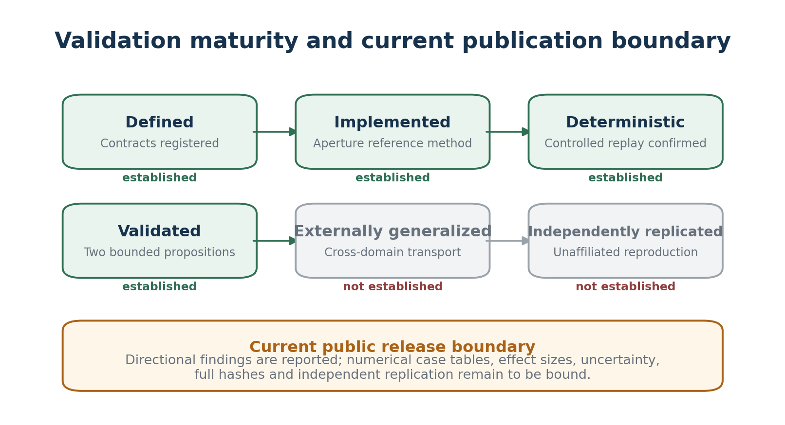
Figure 3. Validation maturity and the current publication boundary.

False-positive and false-negative behavior
The confirmed discrimination result entails successful separation of the tested transition conditions from the included stable and negative controls. However, the absence of a bound confusion matrix prevents calculation of false-positive and false-negative rates. This paper therefore does not translate successful control behavior into a population error estimate.
False positives in this domain include unsupported transition, Basin Exit, collapse, failure, or lead-time findings in stable or target-absent cases. False negatives include failure to identify the declared transition when the required evidence and method conditions are present. Candidate-only, unavailable, and ambiguous states should be reported separately rather than forced into either error category.

Effect size and uncertainty
The directional result “better than declared simple baselines” establishes ordering within the controlled study, not magnitude. The public materials reviewed for this paper contain no bound numerical effect size or uncertainty interval. Reporting a reconstructed number would violate the same evidence-governance principle the study is intended to test.
A release-ready result table should report, at minimum, the number of independent cases by class, the number of related variants, the primary discrimination statistic, the baseline value, the paired or unpaired effect estimate, its uncertainty interval, the resampling unit, and every excluded or inconclusive case.

Failure cases and discrepancies
The Validation Harness preserves not-matched, partially matched, unexpected, unavailable, and inadmissible outcomes. The current technical baseline does not bind a case-level discrepancy ledger for the reported result. This prevents a numerical failure analysis but does not justify treating all 26 inventory cases as successful.
The absence of a published discrepancy ledger is recorded here as a release limitation. Future publication should retain failed and ambiguous cases, because the scientific value of the program depends partly on revealing where the ontology, measurement set, or implementation does not discriminate cleanly.

Interpretation

Significance of deterministic evidence
P1 establishes an essential precondition for cumulative science. A source-bound runtime can be compared across instruments, interfaces, investigations, and preserved artifacts only if its governed identity and core measurements remain stable under eligible replay. This does not make the measurement scientifically correct, but it makes disagreement inspectable. A deterministic method can be challenged at the level of source, transformation, parameter, threshold, or construct rather than through irreproducible presentation.

Significance of controlled discrimination
P2 is the first scientific result for the field. It indicates that selected longitudinal measurements carry discriminative information about specified runtime transitions beyond the declared simple baselines in the controlled corpus. The value of the finding is not that every runtime can now be diagnosed. Its value is that the field's central empirical object—organization through time—produced a testable difference under controlled comparison.
This result justifies a larger validation program. It does not settle which measurement is necessary, whether thresholds transport, whether regimes correspond to external operational outcomes, or whether performance persists under uncontrolled records.

Why both results are necessary
The two propositions constrain different failure modes.
A discriminative but irreproducible method cannot support stable evidence. A reproducible but nondiscriminative method can generate consistent records that say little about the phenomenon. LCD requires both a governed computational object and a measurement that survives comparison with controls.

Evidence-Governed Computation as validation discipline
Evidence-Governed Computation™ extends governance beyond data ingestion. It constrains measurement, classification, synthesis, and reporting to the authority of the evidence that supports them. In this paper, that discipline has a concrete consequence: the two confirmed propositions are reported, while absent numerical tables, hashes, and independent replication are not silently supplied by narrative.
The limitation is therefore part of the result. A validation paper should not acquire greater authority than the validation artifact it describes.

Robustness Tests Required for the Next Release

Ablation
The next bound study should remove, individually and in combinations, temporal structure, persistence and hysteresis, role topology, recurrence, drift, pressure, boundary features, and cross-signal relationships. The objective is to determine whether discrimination is broadly distributed or depends on a narrow component.

Perturbation
Controlled perturbations should test monotonicity and invariance. Harmless formatting changes should not alter scientific findings. Meaningful event-order changes should alter time-dependent results. Removal of a failure anchor should make formal lead time unavailable. Role relabeling should affect role-dependent measurements without changing unrelated source-derived telemetry.

Temporal leakage
Every warning or precursor claim should be recomputed from prefixes ending at the claimed detection coordinate. The prefix result should match the online-eligible state of the full-run computation. Any dependence on later events disqualifies the finding as prospective evidence.

Cross-source-family evaluation
Results should be stratified by source family and by synthetic versus operational origin. A leave-one-family-out design can test whether a measurement captures general longitudinal structure or source-specific formatting. Transport should not be claimed when the target family influenced method selection.

External outcomes and calibration
Operational consequence must be supplied independently of runtime intensity. Boundary pressure, instability, or drift should not be converted into probability of real-world failure without calibrated external outcome data. A future predictive study should prespecify the event definition, eligible evidence horizon, threshold selection procedure, and decision context.

Reproducibility and Replication Package

Required release artifacts
Table 5. Minimum contents of a replication-ready release package.
Artifact | Minimum content | Integrity requirement
Case manifest | Case ID, class, source family, provenance, dependence group, inclusion status | Manifest hash and version
Source bundle | Exact source bytes or authorized immutable references | Per-source hash
Expectation maps | Positive, negative, unavailable, and prohibited outcomes locked before compute | Map hash and lock time
Method bundle | Signal definitions, parameters, thresholds, horizons, persistence rules | Computation-contract hash
Baseline bundle | Baseline algorithms, parameters, and selection procedure | Baseline version and hash
Release bundle | Executable implementation and environment declaration | Build or software hash
Expected outputs | Canonical objects, deterministic fields, numerical tolerances | Expected-output bundle hash
Result tables | Case-level predictions, controls, exclusions, discrepancies, summary statistics | Result-record identity
Evidence artifacts | Runtime Evidence Records, Passports, seals, and preservation manifests | Record and artifact hashes
Replication instructions | Exact commands, environment, comparison procedure, discrepancy taxonomy | Protocol version

Independent replication procedure
An unaffiliated team should:
1. obtain and verify the complete release package;
2. reconstruct the declared execution environment;
3. verify registries, schemas, methods, and case-manifest hashes;
4. confirm that expectation maps are unavailable to the evidence engine;
5. load each source through the registered ingestion path;
6. compare source qualification and canonicalization;
7. compute the Current Evidence Run and Runtime Evidence Record;
8. repeat deterministic cases within and across declared environments;
9. compare the selected LCD method with every declared baseline;
10. execute stable, negative, ambiguous, and missing-evidence cases;
11. run temporal-leakage, perturbation, and ablation protocols;
12. export and reload preservation artifacts;
13. classify every discrepancy; and
14. publish methods, numerical results, hashes, exclusions, failures, and limitations.
Replication may be positive, partial, negative, inconclusive, or blocked by unavailable materials. Each state should remain visible.

Current Publication Boundary

Available and reported
The present record establishes:
- the two-object validation architecture;
- the anti-contamination boundary;
- the two confirmed controlled propositions;
- the current program inventory;
- the distinction between runtime and research signal registries;
- the fourteen-protocol validation framework;
- the required missingness and temporal boundaries; and
- an executable independent-replication procedure.

Not bound in the current public record
The following are not available in the reviewed public materials:
- a complete machine-readable manifest for the 26 reported cases;
- case-class composition and dependence groups;
- replay counts and environment matrix;
- the exact selected measurement subset for P2;
- baseline definitions and parameters;
- train, calibration, and held-out assignments;
- case-level numerical predictions and comparison states;
- confusion matrices, effect sizes, and uncertainty intervals;
- complete ablation, perturbation, and temporal-leakage results;
- cross-source-family numerical results;
- frozen executable and dependency bundle;
- computation, expected-output, result, and artifact hashes; and
- independent replication results.
These are not filled with estimates. Their absence limits the present paper to a controlled validation report rather than a complete independently reproducible empirical package.

Threats to Validity

Internal validity
Potential threats include contamination from fixture identity, thresholds selected after inspecting outcomes, related case variants crossing partitions, circular labels, and case construction that directly encodes the target measurement. The two-object architecture and locked expectation maps reduce but do not eliminate these risks. A public manifest and protected result table are required to audit them.

Construct validity
The selected measurements may distinguish the fixtures for reasons narrower than the intended constructs. A pressure or drift measure might respond to length, lexical repetition, or formatting artifacts rather than a general regime transition. Ablation, perturbation, matched controls, and convergent comparison with independent operational criteria are required.

Statistical conclusion validity
The number of reported cases is not yet a verified number of independent experimental units. Without case-level results, effect estimates and uncertainty cannot be calculated. Any performance percentage inferred from the inventory would be misleading.

External validity
Controlled fixtures may not represent open-ended agent behavior, production incident distributions, different models, other languages, or institutional workflows. Support for several source families demonstrates architectural breadth, not empirical transport.

Reproducibility validity
Same-implementation replay does not establish independent implementation equivalence. Browser, dependency, hardware, serialization, and floating-point differences should be tested under declared tolerances. Frozen release and artifact hashes remain necessary.

Claim Boundary
This paper supports a narrow claim:
Under the declared controlled conditions, selected LCD measurements provide reproducible and discriminative evidence of specified longitudinal runtime transitions.
It does not establish:
- universal validity of LCD constructs;
- access to hidden model state or private reasoning;
- cognition, consciousness, intent, agency, or identity;
- unique or universal causation;
- calibrated probability of operational failure;
- production-level prediction;
- generalization across models, domains, source families, or institutions;
- safety, alignment, compliance, or deployment readiness;
- completeness or truth of the supplied source;
- legal admissibility; or
- independent replication.

Conclusion
This paper reports the first two validated propositions of Longitudinal Computational Dynamics. Within the controlled SubstrateX Aperture program, fixed eligible inputs and governing versions reproduced the same core Runtime Evidence Record, and selected longitudinal measurements distinguished specified transition cases from stable and negative controls better than declared simple baselines.
These results matter because they address the two minimum requirements for a new measurement program: the computation must be stable enough to inspect, and the measurement must differentiate the phenomenon it is intended to represent. Together they move LCD beyond a conceptual vocabulary and toward an empirical science of computational organization through time.
The findings remain bounded. The reviewed public record does not yet contain the numerical result ledger, effect sizes, uncertainty intervals, error matrices, ablation outputs, complete case manifest, frozen release hashes, or independent replication package required for a fully auditable empirical publication. Evidence governance requires that those absences remain visible.
The next scientific step is therefore concrete: bind the controlled results to a complete hashed release, publish the case-level comparison tables, test leakage and component dependence, evaluate held-out source families and independent operational outcomes, and invite unaffiliated replication.
LCD does not become credible because its terminology is comprehensive or its interface is compelling. It becomes credible when its propositions survive controlled comparison, transparent failure analysis, and independent challenge. This paper establishes the first bounded results and the exact evidentiary path required for what follows.

References
1. Asadi A. Longitudinal Computational Dynamics: Foundations for the Study of Computational Organization Across Extended Runtime. Version 1.0. SubstrateX; 2026.
2. Strogatz SH. Nonlinear Dynamics and Chaos With Applications to Physics Biology Chemistry and Engineering. 2nd ed. Westview Press; 2015.
3. Scheffer M, Bascompte J, Brock WA, Brovkin V, Carpenter SR, Dakos V, et al. Early-warning signals for critical transitions. Nature. 2009;461:53-59. https://doi.org/10.1038/nature08227
4. Truong C, Oudre L, Vayatis N. Selective review of offline change point detection methods. Signal Processing. 2020;167:107299. https://doi.org/10.1016/j.sigpro.2019.107299
5. Dakos V, Carpenter SR, Brock WA, Ellison AM, Guttal V, Ives AR, et al. Methods for detecting early warnings of critical transitions in time series illustrated using simulated ecological data. PLoS ONE. 2012;7(7):e41010. https://doi.org/10.1371/journal.pone.0041010
6. van der Aalst WMP. Process Mining Data Science in Action. 2nd ed. Springer; 2016. https://doi.org/10.1007/978-3-662-49851-4
7. Fournier F, Limonad L, David Y. Agentic AI process observability discovering behavioral variability. arXiv; 2025. https://doi.org/10.48550/arXiv.2505.20127
8. Majgaonkar O, Fei Z, Li X, Sarro F, Ye H. Understanding code agent behaviour an empirical study of success and failure trajectories. arXiv; 2025. https://doi.org/10.48550/arXiv.2511.00197
9. Zheng Y, Chang C, Mao Y, Wu T, Huang Y, Ma T, et al. AgentPProf semantic profiler for long horizon AI agents. arXiv; 2026. https://doi.org/10.48550/arXiv.2609.20301
10. Wang Z, Xu Y, Li C, Peng C, Adams B, Hassan AE, Chen TH. Turning interaction history into execution state a runtime layer for long-horizon coding agents. arXiv; 2026. https://doi.org/10.48550/arXiv.2608.00808
11. Souza R, Gueroudji A, DeWitt S, Rosendo D, Ghosal T, Ross R, et al. PROV-AGENT unified provenance for tracking AI agent interactions in agentic workflows. arXiv; 2025. https://doi.org/10.48550/arXiv.2508.02866
12. Moreau L, Missier P, editors. PROV-DM the PROV data model. W3C Recommendation; 2013. https://www.w3.org/TR/prov-dm/
13. Pineau J, Vincent-Lamarre P, Sinha K, Larivière V, Beygelzimer A, d'Alché-Buc F, et al. Improving reproducibility in machine learning research. Journal of Machine Learning Research. 2021;22(164):1-20.
14. Nosek BA, Ebersole CR, DeHaven AC, Mellor DT. The preregistration revolution. Proceedings of the National Academy of Sciences. 2018;115(11):2600-2606. https://doi.org/10.1073/pnas.1708274114
15. Demšar J. Statistical comparisons of classifiers over multiple data sets. Journal of Machine Learning Research. 2006;7:1-30.
16. Raji ID, Smart A, White RN, Mitchell M, Gebru T, Hutchinson B, et al. Closing the AI accountability gap defining an end-to-end framework for internal algorithmic auditing. In Proceedings of the 2020 Conference on Fairness Accountability and Transparency. ACM; 2020:33-44. https://doi.org/10.1145/3351095.3372873
17. Gebru T, Morgenstern J, Vecchione B, Vaughan JW, Wallach H, Daume III H, Crawford K. Datasheets for datasets. Communications of the ACM. 2021;64(12):86-92. https://doi.org/10.1145/3458723
18. Mitchell M, Wu S, Zaldivar A, Barnes P, Vasserman L, Hutchinson B, et al. Model cards for model reporting. In Proceedings of the Conference on Fairness Accountability and Transparency. ACM; 2019:220-229. https://doi.org/10.1145/3287560.3287596
19. National Institute of Standards and Technology. Artificial Intelligence Risk Management Framework AI RMF 1.0. NIST AI 100-1; 2023. https://doi.org/10.6028/NIST.AI.100-1
20. Sculley D, Holt G, Golovin D, Davydov E, Phillips T, Ebner D, et al. Hidden technical debt in machine learning systems. In Advances in Neural Information Processing Systems 28. 2015.

Appendix A Minimum Numerical Result Table
The following table should accompany the next evidence-bound release. Empty fields must remain unavailable until populated from the preserved result record.
Table 6. Minimum numerical result table for the next evidence-bound release.
Field | Required value
Independent transition cases | Count and case IDs
Independent stable controls | Count and case IDs
Independent negative controls | Count and case IDs
Ambiguous or unavailable cases | Count, IDs, and treatment rule
Related variants | Count and dependence groups
Replay repetitions | Per case and per environment
Primary LCD method | Registry IDs, versions, parameters, thresholds
Baselines | Algorithm, version, parameters, selection rule
Primary discrimination statistic | Estimate and direction
Effect size | Definition, estimate, and uncertainty interval
False-positive and false-negative behavior | Counts, denominators, and rates
Exclusions | Case IDs and prespecified reasons
Missingness | Dependency and marker availability by case
Partitioning | Development, calibration, and held-out assignments
Hashes | Source, manifest, methods, build, results, and artifacts

Appendix B Discrepancy Taxonomy
D0 — Exact match. All governed deterministic fields match.
D1 — Permitted envelope difference. Only declared variable metadata differs.
D2 — Numerical tolerance difference. A governed numerical field differs within its declared tolerance.
D3 — Environment-sensitive difference. A difference is reproducibly associated with an environment and requires a contract decision.
D4 — Deterministic-core mismatch. A governed field differs outside its equality rule.
D5 — Authority mismatch. Evidence identity, source binding, marker authority, claim boundary, Passport, or seal relationships disagree.
D6 — Comparison contamination. Expected outcomes, sample identity, rubric state, or interface state entered evidence computation.
D7 — Replication blocker. Required source, method, environment, or artifact material is unavailable.

Appendix C Validation Maturity Statement
The result described in this paper has the following bounded maturity:
- Defined: yes, for the principal scientific and evidence contracts.
- Implemented: yes, in the reviewed Aperture reference implementation.
- Deterministic: confirmed within the controlled validation program.
- Validated: confirmed for the two propositions and controlled conditions stated here.
- Externally generalized: not established.
- Prospectively calibrated: not established.
- Independently replicated: not established.
🔒 Original Research & Provenance Declaration
This work forms part of the scientific and engineering program originated and developed by Arjay Asadi, Founding Architect of SubstrateX® and creator of SubstrateX Aperture™.
The research investigates Intelligence in Motion™: the observable development of computational behavior across extended runtime.
Its current scientific framework is Longitudinal Computational Dynamics® (LCD), which treats Longitudinal Computational Behavior as an empirical object of study: the measurable development of computational activity across ordered execution, including persistence, drift, recurrence, coordination, temporal organization, regime formation, transition, failure, and recovery.
The present body of work emerged from a continuous research program developed between 2024 and 2026, beginning with investigations into inference-phase dynamics, runtime intelligence, recursive behavioral formation, coherence, identity-like persistence, drift, collapse, recovery, and temporal structure.
Earlier publications were developed under the Recursive Science® research program. That work remains part of the documented scientific lineage and foundational provenance of the present framework. Its central runtime-dynamics investigations have since been consolidated, refined, and operationalized within Longitudinal Computational Dynamics®.
The decisive advance of the current program is not simply terminological.
It is the transition from conceptual runtime theory to an integrated scientific and computational architecture in which extended computational behavior can be:
reconstructed, measured, instrumented, investigated, governed by evidence, reproduced, and preserved.
Scientific and Architectural Hierarchy
The canonical hierarchy of the current work is:
Intelligence in Motion™
Governing scientific proposition
Longitudinal Computational Dynamics®
Scientific framework
Longitudinal Computational Behavior
Primary empirical object
Runtime Evidence
Observable evidentiary substrate through which longitudinal computational behavior is reconstructed and examined
Evidence-Governed Computation™
Architectural discipline governing what computational systems may legitimately claim from available evidence
Runtime Evidence Infrastructure
Integrated computational architecture for reconstruction, telemetry, evidence authority, investigation, reproducibility, and preservation
SubstrateX Aperture™
Runtime Evidence Observatory and principal reference implementation of the architecture
Evidence Commons™
Preservation initiative for portable, inspectable, and challengeable Runtime Evidence artifacts

Provenance and Original Contribution
The contribution of this research program lies not in claiming invention of logging, provenance, observability, dynamical systems, evidence theory, audit trails, or mathematical concepts individually.
Its contribution is the integration and operationalization of these and related disciplines around a specific scientific object:
the longitudinal computational trajectory itself as a measurable, evidence-bearing object.
This includes the development and integration of concepts, methods, architectures, and instruments concerned with:
- Canonical Runtime formation
- longitudinal computational trajectories and Worldlines
- Chronodynamics and symbolic runtime time
- behavioral telemetry
- stability, drift, pressure, recurrence, and boundary formation
- governed temporal markers
- Steering Windows and evidence-qualified lead-time
- instrument contracts and bounded scientific projections
- Current Evidence Run identity
- Runtime Evidence Authority
- Runtime Evidence Passport
- reversible evidence lineage
- Guided Investigation
- Operational World Mapping
- evidence preservation and portable Runtime Evidence
- Evidence-Governed Computation
The scientific framework, terminology, architectural relationships, implementation lineage, specifications, manuscripts, validation artifacts, and reference systems associated with this program form part of the documented provenance of the work of Arjay Asadi and SubstrateX®.

Reference Implementation
SubstrateX Aperture™ is the principal operational reference implementation of this research program.
Aperture demonstrates how heterogeneous operational records can be qualified, canonicalized, reconstructed into longitudinal computational trajectories, measured through governed instrumentation, bound to a common evidence identity, subjected to explicit claim boundaries, investigated through reversible source relationships, and preserved as portable Runtime Evidence.
Aperture does not establish the scientific validity of every proposed measurement merely by implementing it.
Implementation establishes that the architecture is computable and operationalizable.
Scientific validity remains subject to calibration, falsification, comparative evaluation, replication, and independent scrutiny.

Recommended Citation
For papers within the Longitudinal Computational Dynamics series:
Asadi, A. (2026). [Paper Title]. Longitudinal Computational Dynamics Series. SubstrateX®.
Where the paper concerns Aperture directly:
Asadi, A. (2026). [Paper Title]. SubstrateX Aperture™ Technical and Scientific Series. SubstrateX®.
Foundational works published previously under Recursive Science® should retain their original citation and publication identity as part of the historical research record.

Scope Clarification
Longitudinal Computational Dynamics® is not a theory of hidden machine thought, consciousness, intent, or inaccessible internal mental state.
It concerns the observable and computationally reconstructed development of behavior through runtime.
Geometric, kinetic, dynamical, temporal, energetic, basin, field, pressure, curvature, and related terminology used within this research refers to declared computational representations and measurement frameworks unless an external physical measurement is explicitly supplied.
Similarly, Evidence-Governed Computation™ does not certify objective truth.
It governs the relationship between:
evidence → method → admissible claim → presentation → preservation
under declared computational rules and evidentiary boundaries.

Copyright, Research Use & Licensing
© 2024–2026 Arjay Asadi. All Rights Reserved.
This work is shared for non-commercial research, education, scholarly discussion, scientific evaluation, and intellectual exchange.
No commercial rights are granted.
Except where a separate written license explicitly provides otherwise, no permission is granted to commercially reproduce, implement, sublicense, redistribute, incorporate into a competing product or service, or commercially exploit the associated:
SubstrateX® architectures, SubstrateX Aperture™ implementations, Longitudinal Computational Dynamics® methods, Evidence-Governed Computation™ specifications, instrumentation systems, software, diagrams, validation materials, or proprietary technical artifacts.
Research citation, critique, scientific evaluation, and non-commercial scholarly discussion are permitted subject to applicable copyright law and attribution requirements.
Commercial implementation, licensing, partnership, or derivative commercial use requires prior written authorization from Arjay Asadi / SubstrateX®.
SubstrateX®, SubstrateX Aperture™, Intelligence in Motion™, Longitudinal Computational Dynamics®, Evidence-Governed Computation™, Evidence Commons™, and associated names, marks, systems, and published materials remain subject to their respective intellectual-property rights.

